|  |  |  |
| --- | --- | --- |
| Product Catalogue | Dial switch |  |
| Type | Linear, raised type |  |
| Rated current | 25mA |  |
| Rated voltage | 24V |  |
| Circuit structure | Single-pole single throw |  |
| Number of switches | 3 |  |
| Pin style | PC pin |  |
| Pin spacing | 2.54mm |  |
| Working temperature | -20℃~+70℃ |  |
| Service life | 3000 |  |
| Color | Red |  |

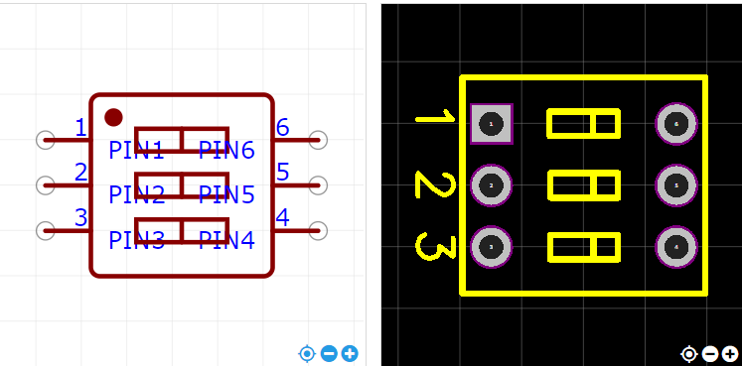

<https://item.szlcsc.com/300153.html>